AMERICAN SOCIETY FOR PUBLIC ADMINISTRATION (ASPA)

By Barry Hunt, MPA

Here are two photos of a most enjoyable buffet reception at the New Otani Hotel in Little Tokyo, Los Angeles, on November 15, 2007. There we met the new National President of the American Society for Public Administration (ASPA), Dr. Harvey White. About 50 attended and many spoke several Asian and European languages. We discussed everything from international public administration and commerce to architecture, education, cuisine and high-speed maglev trains.

The first picture shows some past and present officers of the Los Angeles Chapter of ASPA and supporters. On my right in the photo is past President Jane Pisano (the current Director, L.A. County Natural History Museum). On Jane’s right is Dr. Harvey White. We all had a good time socializing, networking and of course, noshing.

Dr. Harvey gave an inspirational stump speech. He reminded us to be proud that since 1939, ASPA has been the nation's largest and most respected society of professionals in the public service arena. Members advocate greater effectiveness in government by bridging theory and practice to foster professionalism and good citizenship.

Through ASPA meetings and publications, members explore functional areas (budgeting, personnel), substantive fields (health, environment, defense) and topical issues (quality, productivity) in public affairs. They focus on all levels of government (from local to international), as well as non-governmental and non-profit players that affect public policy.

ASPA's online career center offers useful information about our profession. ASPA also advocates internationally through growing affiliations with like-minded organizations in several countries on all continents. You, too, are welcome to attend L.A. ASPA meetings and to network with local agency leaders and to gain the benefits of membership.

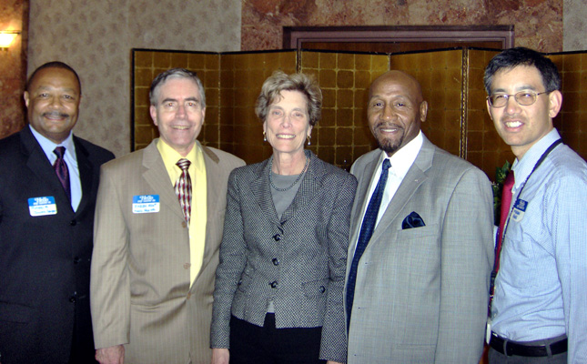

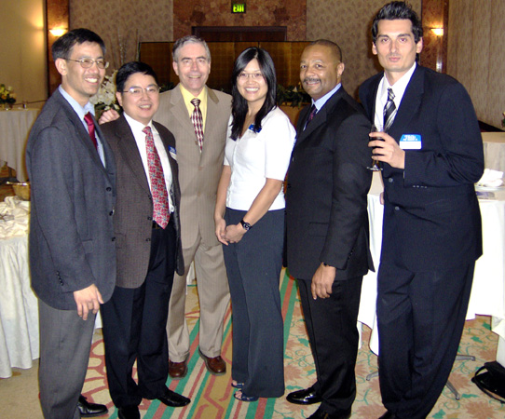

Barry Hunt, MPA

